Course work

Artur Podpalov

#### **Overall Description of Schemas**

**OLTP Database Schema:**

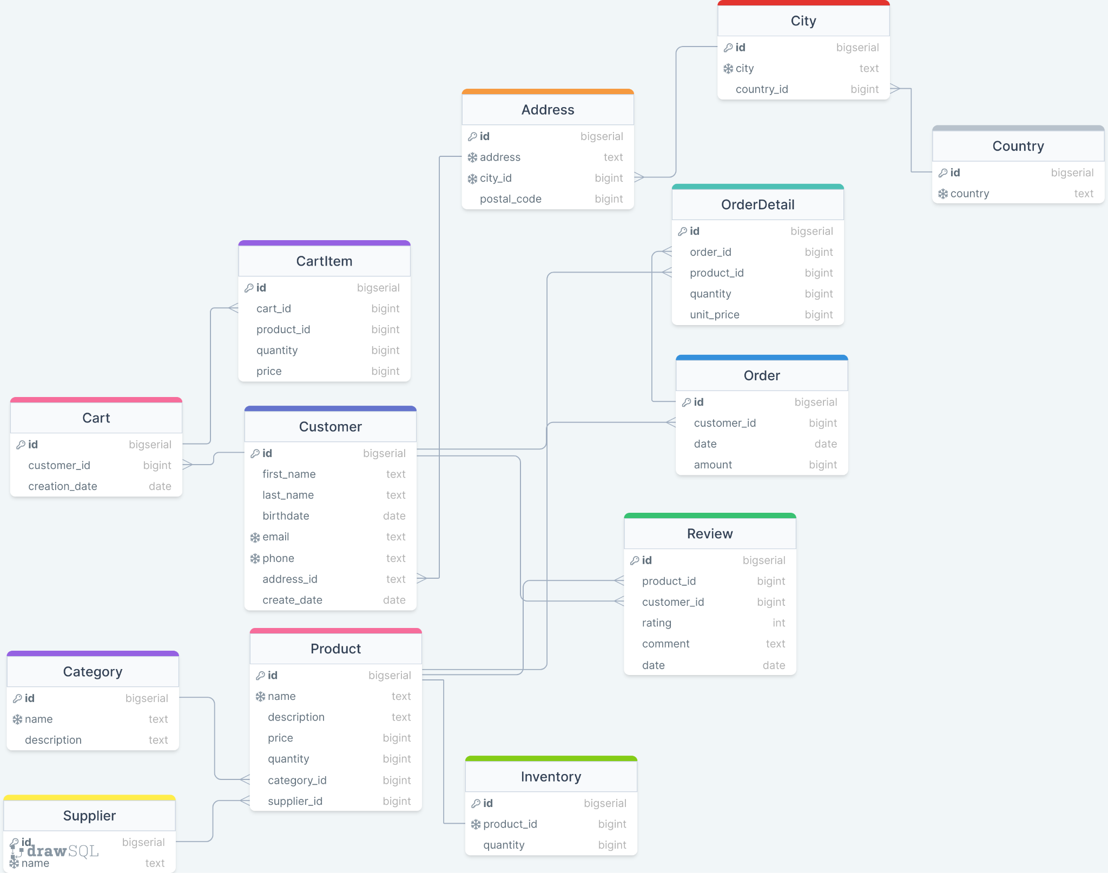

* **Customer**: Stores customer information including first name, last name, birthdate, email, phone, and address.
* **Address**: Stores address details with a link to the city.
* **City**: Stores city information linked to the country.
* **Country**: Stores country information.
* **Order**: Stores order details including customer ID, date, and amount.
* **OrderDetail**: Stores details for each order, including product ID, quantity, and unit price.
* **Product**: Stores product details, including name, description, price, category, and supplier.
* **Category**: Stores product categories.
* **Supplier**: Stores supplier details.
* **Review**: Stores customer reviews for products.
* **Cart**: Stores cart details linked to customers.
* **CartItem**: Stores items in a cart, including product ID and quantity.

**OLAP Database Schema:**

* **Dim_Customer**: Dimension table storing customer information.
* **Dim_Product**: Dimension table storing product details.
* **Dim_Time**: Dimension table storing time-related data.
* **Dim_Order**: Dimension table storing order information.
* **Fact_Sales**: Fact table storing sales data.
* **Fact_Payment**: Fact table storing payment data.

#### **Overall Description of Main Functions and Procedures**

**ETL Process**:

1. **Extract Data**: Extracts data from the OLTP database.
2. **Transform Data**: Applies necessary transformations, such as calculating total sales.
3. **Load Dimension Tables**: Loads data into dimension tables (Dim_Customer, Dim_Product, Dim_Time, Dim_Order).
4. **Load Fact Tables**: Loads transformed data into fact tables (Fact_Sales, Fact_Payment).

**Scripts**:

* **etl_script.py**: Contains the ETL process to extract, transform, and load data from the OLTP database to the OLAP database.
* **script.py**: Includes functions to load initial data from CSV files into the OLTP database.

#### **Instructions**

**1. Setting Up the OLTP Database:**

1. **Create the OLTP Database Schema**:
   * Run the SQL script to create the OLTP database schema.

**Load Data into OLTP Database**:

* Execute script.py to load data from CSV files into the OLTP database.

**2. Setting Up the OLAP Database:**

1. **Create the OLAP Database Schema**:
   * Run the dwh_schema.sql script to create the OLAP database schema.

2. **Run the ETL Process**:

* Execute etl_script.py to perform the ETL process from OLTP to OLAP database.